UFC Fight Outcome Predictor
A Machine Learning Approach to Combat Sports Prediction

Ray Kurhasaj
github.com/raykurhasaj12

Machine Learning Project — 2026

Contents
1. Objective 3
2. Framework of the Project 3
3. Data Acquisition and Extraction 3
4. Model Development 3
4.1 Exploratory Data Analysis 3
4.2 Statistical Significance Testing 4
5. Logistic Regression Model 6
5.1 Model Results and Coefficients 6
6. Random Forest Model 7
7. Hybrid Model 8
8. Data Bias 8
9. Final Hybrid Model 9
10. Neural Networks and Final Model 10
10.1 Final model 11
11. Monte Carlo Simulation 12
12. Interactive User Interface 13
13. References 15

1. Objective
This project's aim is to develop a UFC outcome predictor. I want to create an accurate model looking at significant factors to hopefully predict accurately UFC fight outcomes. I picked UFC due to the simplicity of the outcome being binomial. Does the fighter lose or win (Note: UFC fights do include draws but in this project any draw would be considered as a loss, this will keep it binomial). UFC is also one of the least researched sport markets due to it being relatively new, and not having that much volume of bettors relative to NFL and football etc. Since there is not as much capital betted on this market bookies allocate fewer resources to pricing UFC accurately. This gives informed bettors potential opportunities of an edge. The goal is to understand the model, implement machine learning, and create an interactive UI that applies my model to upcoming fight cards. I have experience in creating models via my mathematics degree and limited use of Machine Learning.

2. Framework of the Project
This project follows a structured six-stage pipeline, progressing from raw data acquisition through to an interactive prediction tool.
1. Data Acquisition and Extraction
2. Feature Identification and Significance Testing
3. Model Development
4. Model Validation
5. Monte Carlo Simulation
6. Interactive User Interface

3. Data Acquisition and Extraction
Data extraction is one of the biggest barriers of entry to data scientists, often requiring time investment and considerable financial cost. Luckily, data was sourced from Kaggle (Ufcdata, Rajeev Warrier, 2021), originally scraped from UFCStats.com, the official statistical repository for UFC fight data.

This dataset has 5,902 fights with 160 features. It contains each fighter's historical average calculated up to the date of each fight, meaning no post-fight data is incorporated into any pre-fight feature. This is a critical point and prevents data leakage, ensuring the model only has access to information that would have been available prior to the fight. For each fight the outcome is recorded as either Red or Blue, depending on which corner won. Nine advantages were computed by working out the difference between the following key metrics: reach, height, age, significant strike accuracy, knockdown average, takedown accuracy, submission attempt average, current win streak, and control time.

4. Model Development

4.1 Exploratory Data Analysis
Prior to model construction we first had to determine which of our advantage factors showed association with fight outcomes through both visual and quantitative methods. We plotted each advantage against win% for each fighter. To ensure statistically reliable estimates at each point, on the X axis we distributed our advantages into intervals which adjust for sample size. We want a sample size to be shared equally among intervals. This approach prevents low sample bins from producing misleading win rate estimates at the extremes of the distributions. Rather than framing outcomes from the red corner's perspective, which would introduce bias given that the red corner wins approximately 67% of fights in the database, outcomes were reframed from the advantaged fighter's perspective. Looking at our plots, we see approximately every advantage shows a positive correlation with win rate, but not all of them behave in a way where the larger the advantage is the higher the chances of winning the fight. But from inspection all these factors exhibit sufficient visual evidence of a directional relationship to warrant inclusion as candidates for the predictive model.

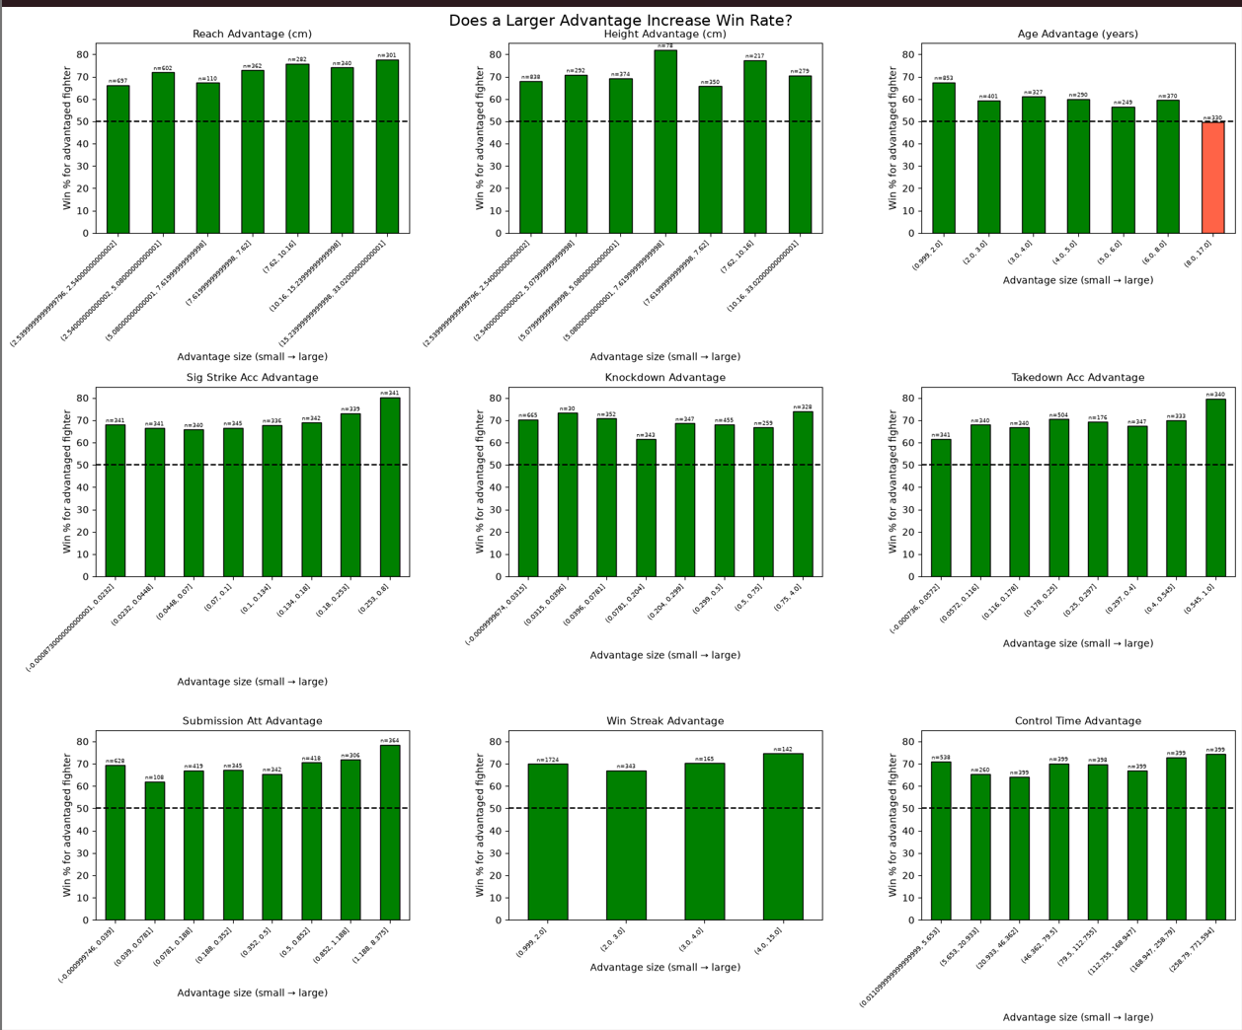
Figure 1: Win rate by advantage size for all nine factors (bias-corrected, equal-frequency bins)

4.2 Statistical Significance Testing
Visual inspection alone is not sufficient to be confident that we should include these factors in our model. To quantify significance a Point Biserial Correlation test was applied to each feature. We used a Point Biserial Correlation test due to the structure of our data. Each advantage feature is a continuous variable whilst the fight outcome is binary.

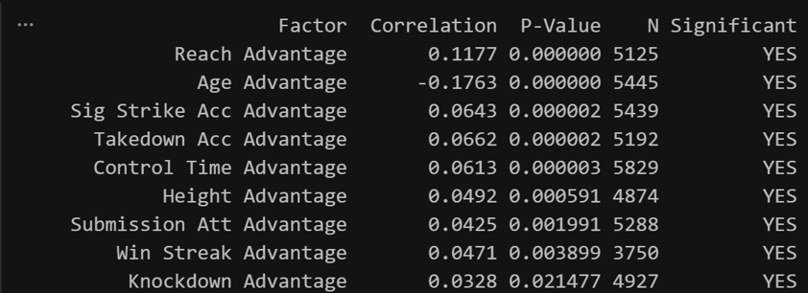
Figure 2: Point Biserial Correlation results for all nine advantage features

We see that all factors are statistically significant at the 1% significance level, and knockdown advantage is significant at the 2.5% significance level. These results confirm that the observed correlations are unlikely to have arisen by chance alone and provide quantitative justification for the inclusion of all nine features in the predictive model.

5. Logistic Regression Model
Logistic regression models are used for binary outcome problems. It models the probability that a given observation belongs to one of the outcome classes. By passing a linear combination of input features through the sigmoid function P(Y=1) = 1 / (1 + e^(-z)) it provides an output in the range [0,1]. Where z is the linear combination of features: z = β₀ + β₁x₁ + β₂x₂ + ... + βₙxₙ. Here xᵢ will be our nine advantage factors and βᵢ will be our coefficients for each factor. The sigmoid function maps any real value of z to a probability between 0 and 1.

Here is where machine learning comes into play. The way Python's logistic regression works is the model learns the optimal coefficients through maximum likelihood estimation and gradient descent. It iteratively adjusts coefficients in the direction that reduces prediction error, continuing to do this thousands of times until it concludes. The model has, in effect, learned from its own prediction errors, which is the fundamental principle of machine learning. Logistic regression is highly interpretable, computationally efficient, and robust on tabular datasets of this size.

5.1 Model Results and Coefficients
The table below presents the final coefficients obtained after training on 4,721 fights. Figures 3 and 4 show the coefficient chart and model evaluation outputs respectively.

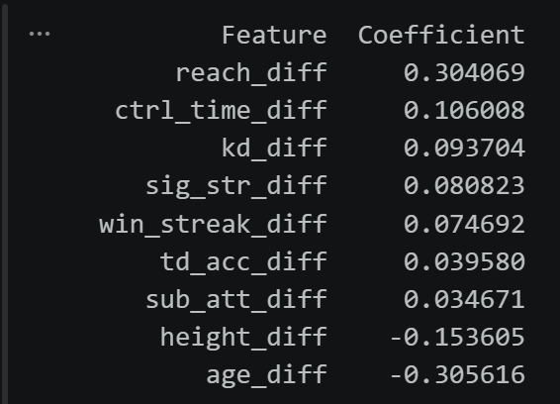
Figure 3: Logistic regression coefficient values and feature importance ranking

We have determined all our coefficients for each factor and tested it across our data. Our model had an accuracy of 68.9%, this means 68.9% of the predicted winners won. This is very high and suggests are model does have predictive value. Sport predictive models that have an over 60% win rate are considered to be a confident model and have predictive value. All our confidence win rates lied inside the intervals suggesting our predictions were accurate apart from the 80-90% confidence band. This band had a win rate of 74.5%, this suggests our model over estimates these fighters win probability. If we can alter this prediction interval it could increase our model accuracy even further. This is when I tested a Random Forest model.

6. Random Forest Model
A random forest model is a machine learning algorithm that constructs many individual trees and aggregates their predictions through a majority voting mechanism. A single decision tree partitions data through a series of binary yes/no splits, recursively dividing the data until reaching a terminal mode that outputs a prediction. A single decision tree is highly unstable since small changes in data can produce an entirely different tree structure. The model tends to overfit by memorising training data rather than learning generalisable patterns.
Random tree forest addresses this by each tree being trained on a random sample of the training data, introducing variation across tress. As well as this at each split point within a tree only a random subset of features is considered rather than all nine. This prevents any single dominating factor from structuring every tree identically. The result is a diverse collection of 500 trees each trained on sightly different data and factors. All of these make slightly different predictions, and the final output is the average of the 500 predictions. Compared to logistic regression, random forest captures nonlinear relations, and feature interactions like for example the combined effect of reach advantage and win streak. Unlike logistic regression there is no single equation describing the random forests decision process.

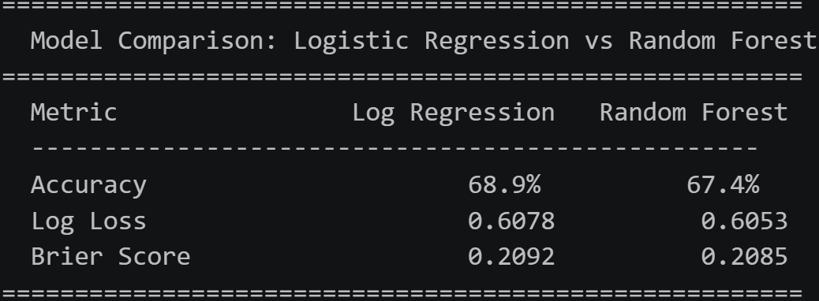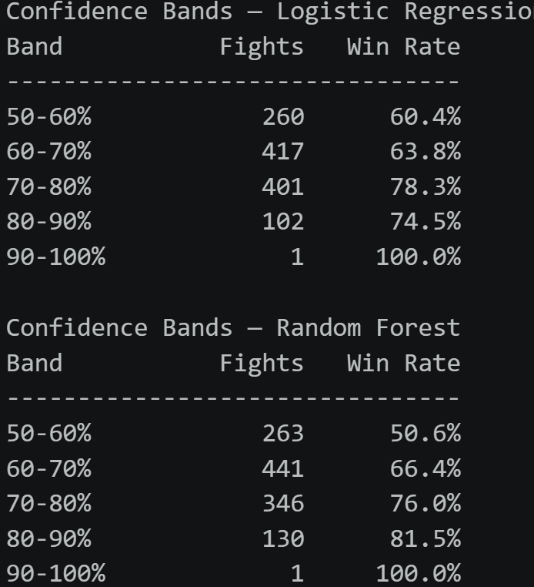
Figure 4: Logistic Regression vs Random Forest confidence band comparison

The random forest model had a slightly lower accuracy of 67.4% compared to the logistic regressions of 68.9%. So one may assume we just ignore our random forest model however it does provide useful information. One of the faults in our logistic regression model was the overestimated predictions in the 80-90 % interval, this interval had a win rate of 74.5%. This is not efficiently accurate for a model. However once we see the random forests confidence band we see the respective confidence band has a 7% increase to 81.5%. This is a relatively significant improvement.

7. Hybrid Model
The hybrid model was developed to combine the complementary strengths of logistic regression and random forest. What our hybrid model does is we use our logistic regression model to predict a fight outcome but if the logistic regression predicts a fighter to have an 80-90% chance of winning we then use the random forest model to predict this outcome. This captures the benefits of both approaches. This model has a win percentage that lies between all intervals and has a high accuracy of 68.9%.
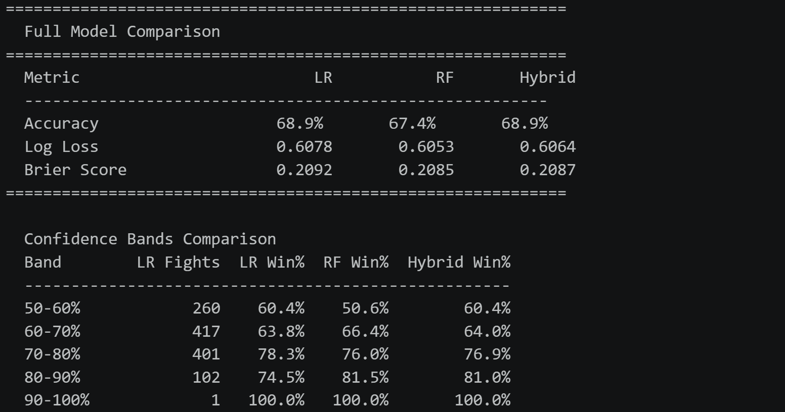
Figure 5: Full model comparison — Logistic Regression, Random Forest, and Hybrid across all metrics

8. Data Bias
Whilst in sample performance extremely strong I was weary of our results. A model this accurate is considered to have real predictive value. A decent model will have an accuracy of 55-65%, this model exceeds this and has an accuracy of 68.9%. In a sport like MMA where one strike could completely alter the fight outcome we expect some predictions to be incorrect so 68.9% is a good result. Due to my suspicions I was concerned about data bias, our logistic regression coefficients were not already determined coefficients it was instead coefficients determined by the results of our data. So our model may have been been meticulously selecting its coefficients to obtain the best results for this specific data set rather than the factors real coefficients. To investigate this out of sample validation, post 2021 fight data was pursued.
Data acquisition for the out of sample test presented significant challenges. No publicly available data set was found which contained pre fight data from 2021 onwards with all nine required factors. A custom Selenium based web scraper was therefore developed to collect 2346 fights from UFCSTATS.com covering 2022-2026. Two limitations occurred from this process, unlike our original data set I was not able to obtain pre fight data instead I was only able to use current fight data. So I used their total averages for the factors. This introduces a degree of look ahead bias. The second Limitation was I was not able to scrape knockdown differential and control time. Given this constraint I removed these factors from our model and created a seven factor model to allow for consistent comparison between our in sample and out of sample periods.

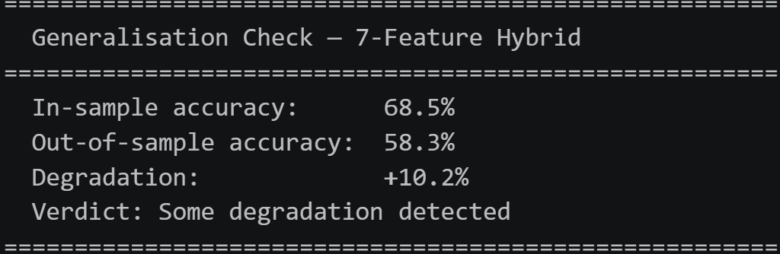
Figure 6: Generalisation check — 7-feature Hybrid model in-sample vs out-of-sample accuracy
When applied to the 2022-2026 out of sample data, we detected the degradation of 10.2%. So we do our model still has some accuracy since it is above 58.3% but we are not seeing extreme prediction accuracy of 68.5% that we saw in the in sample period. However I was curious whether our results was mainly due to our out of samples limitations we discussed about previously. So I then created 3 test periods: pre 2019, 2019-2021 and 2021 onward. 2019-2021 data does not have these limitations and has the same structure of our pre 2019 data. So if pre 2019 and 2019-2021 were found to have performed similarly we could conclude that the degradation result we obtained was due to our data limitations rather than data bias.

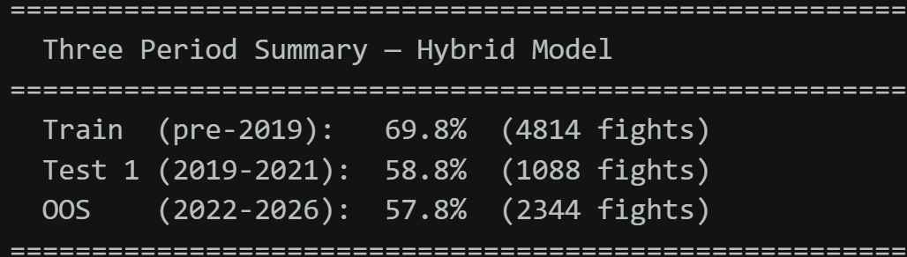
Figure 7: Three-period accuracy summary — Hybrid model trained pre-2019
We see the accuracy of 2019-2021 also fell to 58.8% ruling out data quality as the primary explanation to our degradation. The degradation was consistent regardless of dataset source, confirming genuine concept drift. The model had learned patterns specific to its training era that did not fully transfer to subsequent years.

9. Final Hybrid Model
A final hypothesis was considered, Due to the model accuracy decreasing so significantly I was concerned about the data being skewed by pre 2010 data. UFC is a relatively new organization and the years before 2010 had different rules, fighter pools and competitive consistency. To address this a new test period 2010-2018.The hybrid models coefficients were derived exclusively from this period, then performance will be evaluated on 2019-2021 and post 2021.
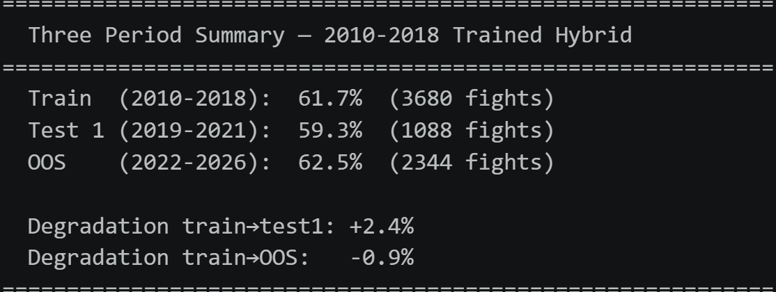
Figure 8: Three-period accuracy summary — 2010–2018 Hybrid model (train 61.7%, holdout 59.3%, OOS 62.5%)
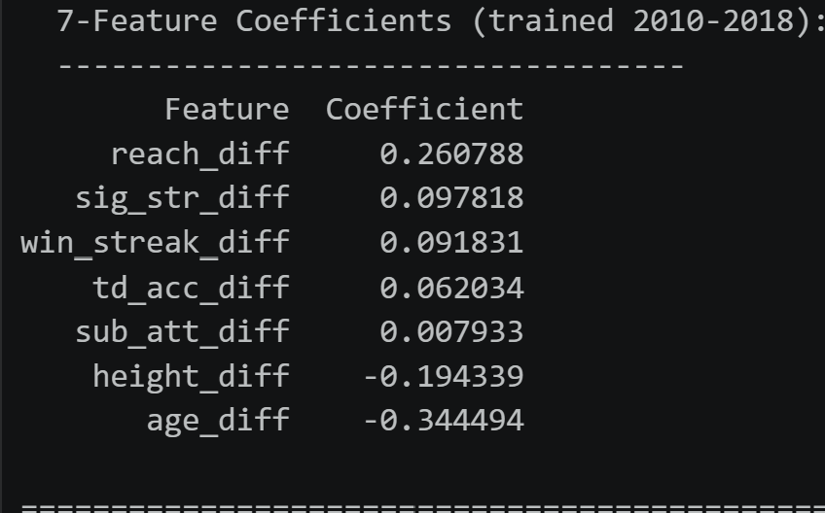
Figure 9: Final 7-feature model coefficients trained on 2010–2018 data
Although our prediction win rate decreased from 69.8% to 61.7% we see it performs consistently across all three periods with a win rate of approximately 60%. A model with consistency is more desirable than a model with unreliable results overfitted to its training period, particularly in a domain such as sports prediction where conditions evolve over time. The reduction in accuracy is not seen as a failure but as evidence that it is no longer memorising historical noise. We were able to remove data bias and now have a model we can forward test on live fight cards.

10. Neural Networks and Final Model
Neural Networks is a machine learning algorithm that consists of layers of interconnected nodes, where each connection has a learned weight. The data passes through layer by layer learning from each input to obtain a final output. It initialises with random weights and goes through multiple iterations and epochs with our training data to determine patterns and predictions. Backpropagation then computes how much each weight contributed to the error and nudges each slight in the direction that reduces loss ( a process known as gradient descent).
Key difference from our other models:
- Logistic regression learns one independent weight per feature
- Random forest learns hard threshold splits on feature combinations
- Neural network learns continuous weighted combinations theoretically capable of capturing more complex non-linear relationships.
We created two neural networks one created with sklearn and one using pytorch, Sklearn is a library which produces the neural network with relative ease through its familiar api, whereas pytorch is the more universal used library across industries. Pytorch allows you delve deeper and has a greater architerctural control and customisation. In our case the pytorch network perfromed marginally worse so it didn’t warrant the complexity. The scikit-learn neaural network was configured with a three-layer archtecture of 128,64, and 32 hidden nodes respectively, trained on 2010-2018 dataset using the same seven factors in the hybrid model. Results across all three period are provided below.

Figure 10: Sklearn neural network — three-period accuracy summary

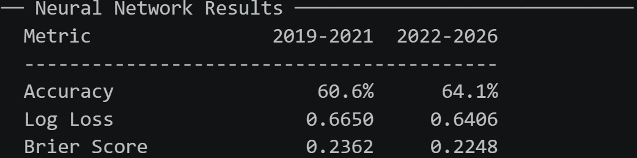
Figure 11: Neural network in-sample accuracy (2010–2018 training period)

These results are impressive as they are above 60% across the three periods, are consistent and have a 3.5% percent accuracy interval and do not contain data bias. Our final period 2022-2026 showed higher accuracy then then our training period 2010-2018 suggesting the model has generalised well rather than memorised training patterns.

10.1 Final model

Through thorough investigation and fine tuning we have created three models, these models have been consistent unbias and have shown potential evidence having predictive information. The model we are going to use for a website is a consensus model, the model will be a combination of our hybrid model as well as our neural network. If both models are within 5% of agreement there is strong evidence that the prediction for the respective fight is correct. A 2.5% agreement interval produced the highest percentage accuracy but there was only approximately 45% of the fights which produced a valid consensus. When you also include the fact we need a fight to have a positive EV this will reduce the amount of possible bookie odds we can exploit to a very low percentage where the model will then become pointless. So 5% was the value I believe contained the balance required for an accurate model and possible fight cards to exploit. 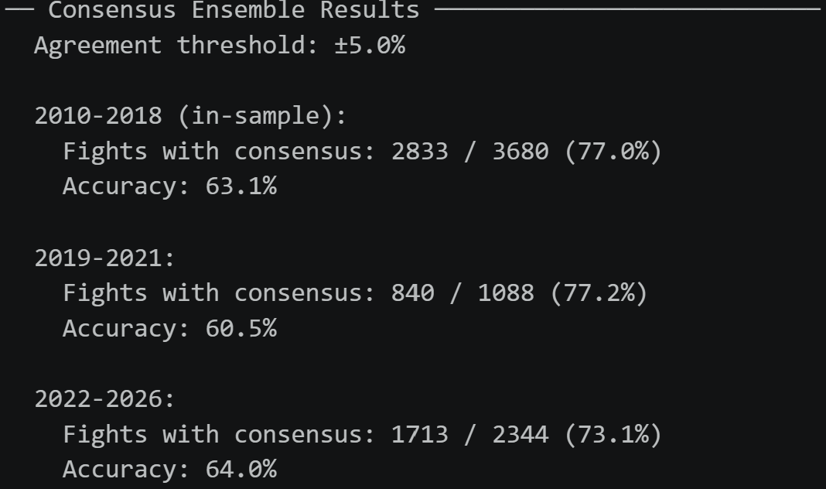
Figure 12: Consensus Ensemble results across all three temporal periods

Two independent modelling approaches arriving at the same conclusion independently reinforces confidence in that prediciton. We prodcued an out of sample accuracy of 64% whilst retaining consensus coverage of approximately 73% of fights, providing a sufficient volume of prediciton per card from which expected value opportunities can be identified.

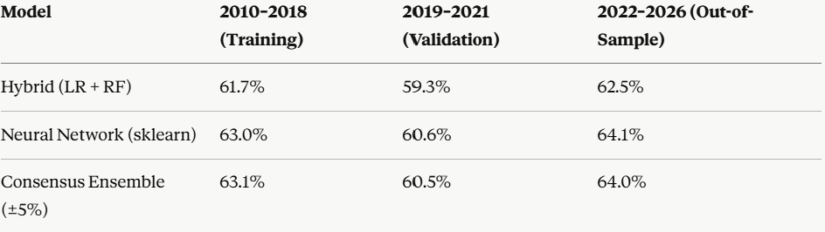
Figure 13: Final model comparison — Hybrid LR/RF, Neural Network, and Consensus Ensemble

11. Monte Carlo Simulation
To quantify the uncertainty of place multiple bets on a single fight card I implemented a monte carlo simulation. The simulation repeatedly samples from the probability distribution of each bet. Across 10,000 simulations we determine the accumulated profit or loss for that scenario. Essentially if we placed the total bets in the fight card 10,000 times what would the expected/average profit be. Key statistics we extracted the expected profit, median outcome, 95th percentile and the 5th percentile. This approach acknowledges that even a model with genuine predictive edge will produce losing cards in the short term due to variance, and frames betting performance as a long-run proposition rather than a short term outcome.

12. Interactive User Interface
So we have created our model that takes into account 7 significant factors to create a prediction on which fighter will win a fight. We have altered for data bias and confidence interval and produced a consistent model relevant to modern MMA. A monte carlo simulation was produced to determine how many iterations of our bets would be profitable. To determine whether we would place a bet we used a concept known as expected value. Expected value is the profits we would expect from a single bet if we placed it an infinite number of times. A positive expected value could occur when a bookie underestimates a fighters odds compared to our models predictions.
The expected value formula we used was
EV = (Model probability x (bookie odds – 1) x stake) – ((1- model probability x stake)

13. References
Warrier, R. (2021). UFC Data [Dataset]. Kaggle. https://www.kaggle.com/datasets/rajeevw/ufcdata
UFCStats.com — Official UFC Statistics Repository. http://www.ufcstats.com

